Game Design Document

Fill up the following document

1. Write the title of your project.

**MAZE RUNNER**

1. What is the goal of the game?

***TO REACH THE TROPHY***

1. Write a brief story of your game.

*Note : All images and characters are edited and*

*created by me. So, there is a copyright policy.*

*The name of player of my game is Spike.*

*The player has to reach the trophy by avoiding*

*the obstacles in game.*

1. Which are the playing characters of this game?

* Playing characters are the ones who respond to the user based on the input from the user.
* Cars, monkeys, Dinos, wizards, etc., are the playing characters in the game.

|  |  |  |
| --- | --- | --- |
| Number | Character Name | What can this character do? |
| 1 | Spike | Play the game |
| 2 | Cactus | Obstacle |
| 3 | Balls | Obstacle |
| 4 |  |  |
| 5 |  |  |
| 6 |  |  |
| 7 |  |  |
| 8 |  |  |

1. Which are the Non-Playing Characters of this game?

* Non-Playing characters are the ones that don't have an action or behavior when the user interacts with the game.
* Hurdles, stones, bananas, coins, etc., are non-playing characters in the game.

|  |  |  |
| --- | --- | --- |
| Number | Character Name | What can this character do? |
| 1 | Walls | Boundry of the game |
| 2 |  |  |
| 3 |  |  |
| 4 |  |  |
| 5 |  |  |
| 6 |  |  |
| 7 |  |  |
| 8 |  |  |

Draw your imagination of this game. What does this game look like?

* Draw the game either on your computer or on paper.
* Add images of the game scenes to show each of the playing and non-playing characters at least once.

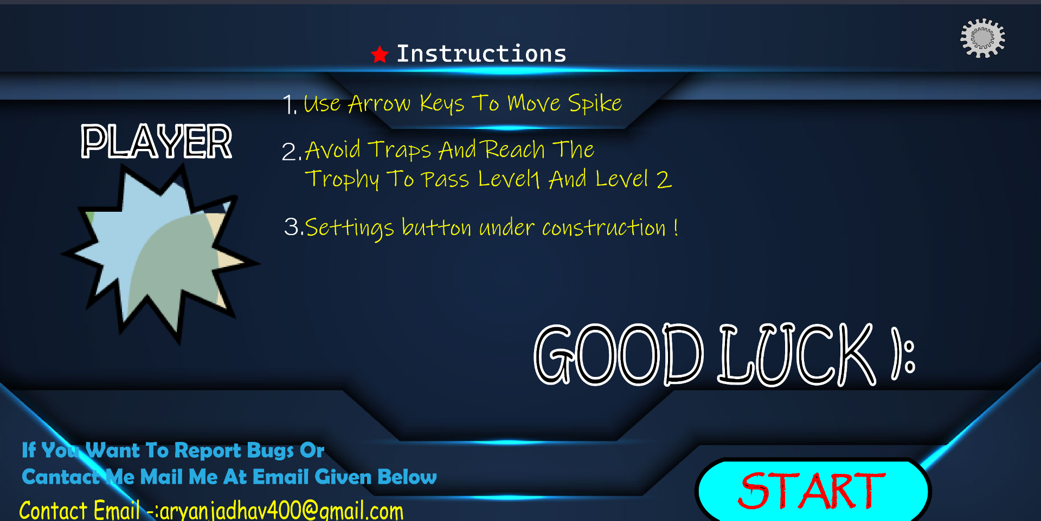

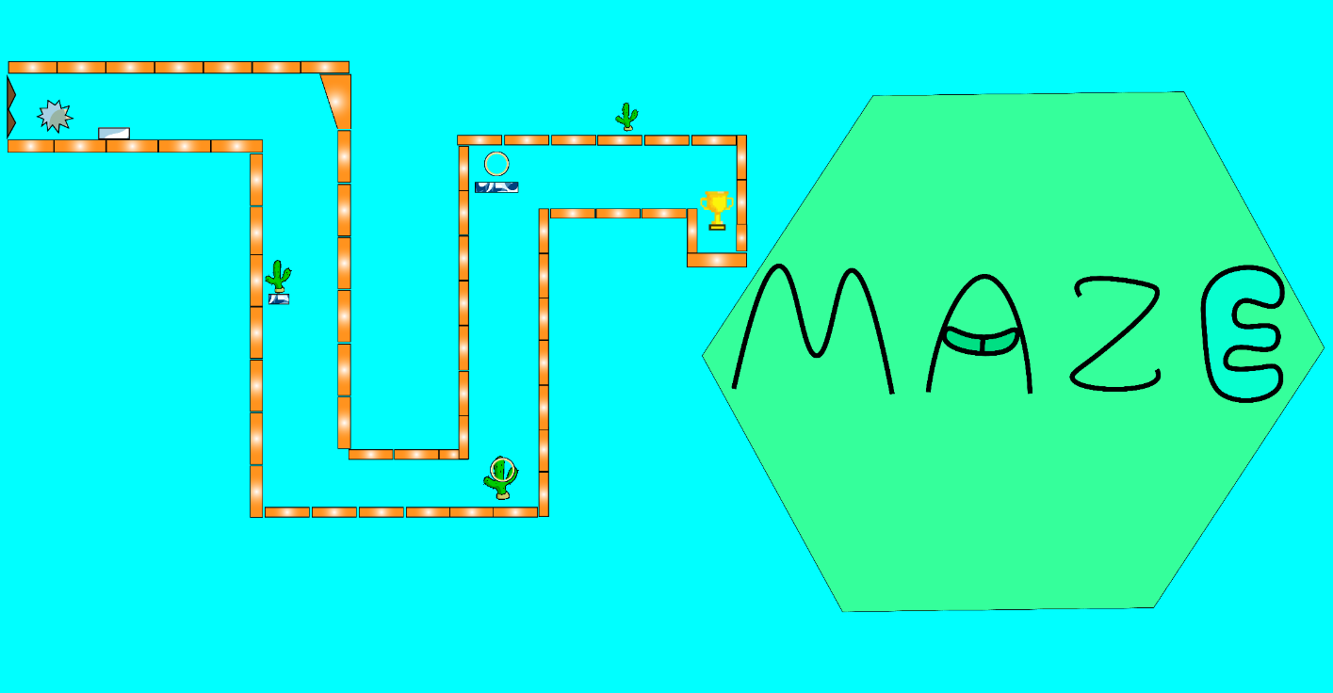

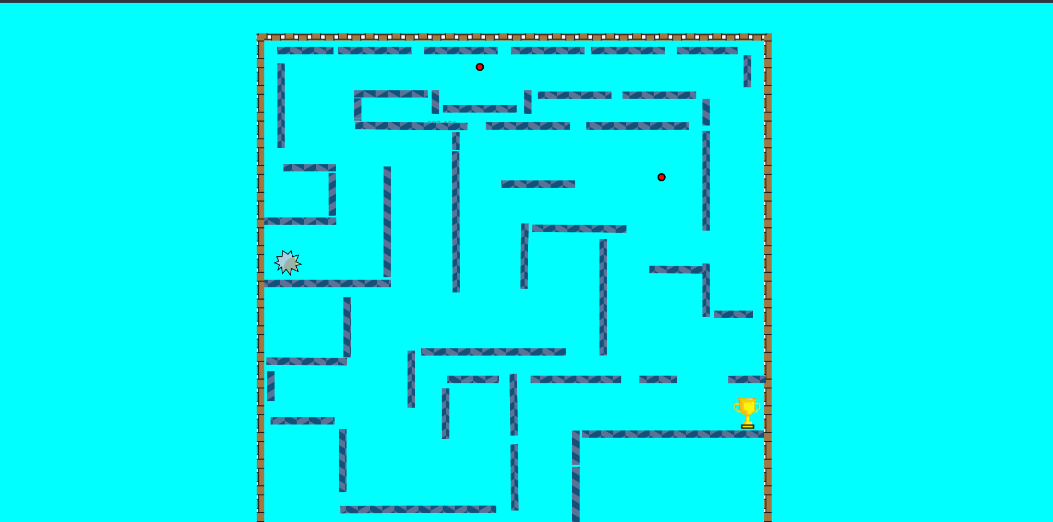

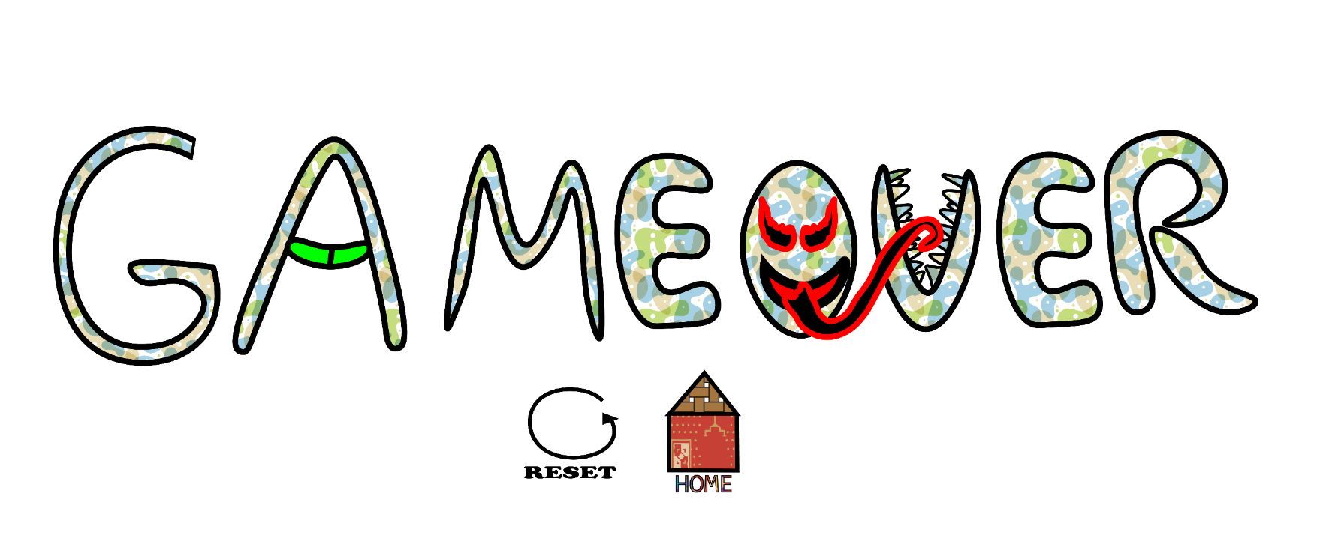





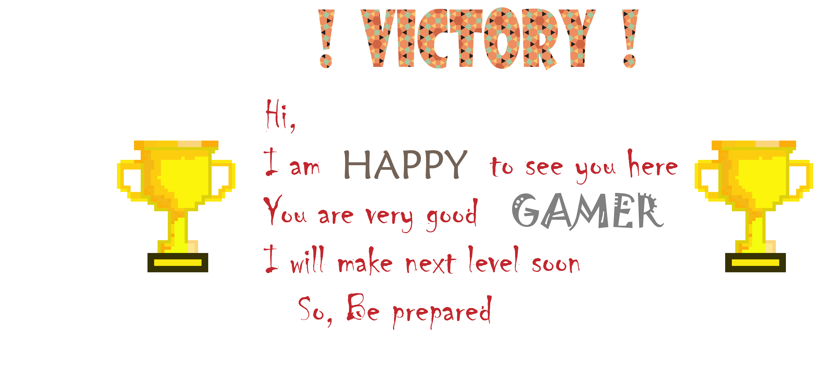

How do you plan to make your game engaging?

I am going to add Currency And a shop and make more levels in game to make it interesting.